**TASK 10 : configure docker using ansible playbook**

**🔰Write an Ansible PlayBook that does the   
following operations in the managed nodes:  
🔹 Configure Docker  
🔹 Start and enable Docker services  
🔹 Pull the httpd server image from the Docker Hub  
🔹 Run the docker container and expose it to the public  
🔹 Copy the html code in /var/www/html directory  
and start the web server**

**Installing ansible in Management Node**

• yum install ansible

**Configuring Ansible**

=> Creating ansible config file

**-- mkdir /etc/ansible**

**-- vi /etc/ansible/ansible.cfg**

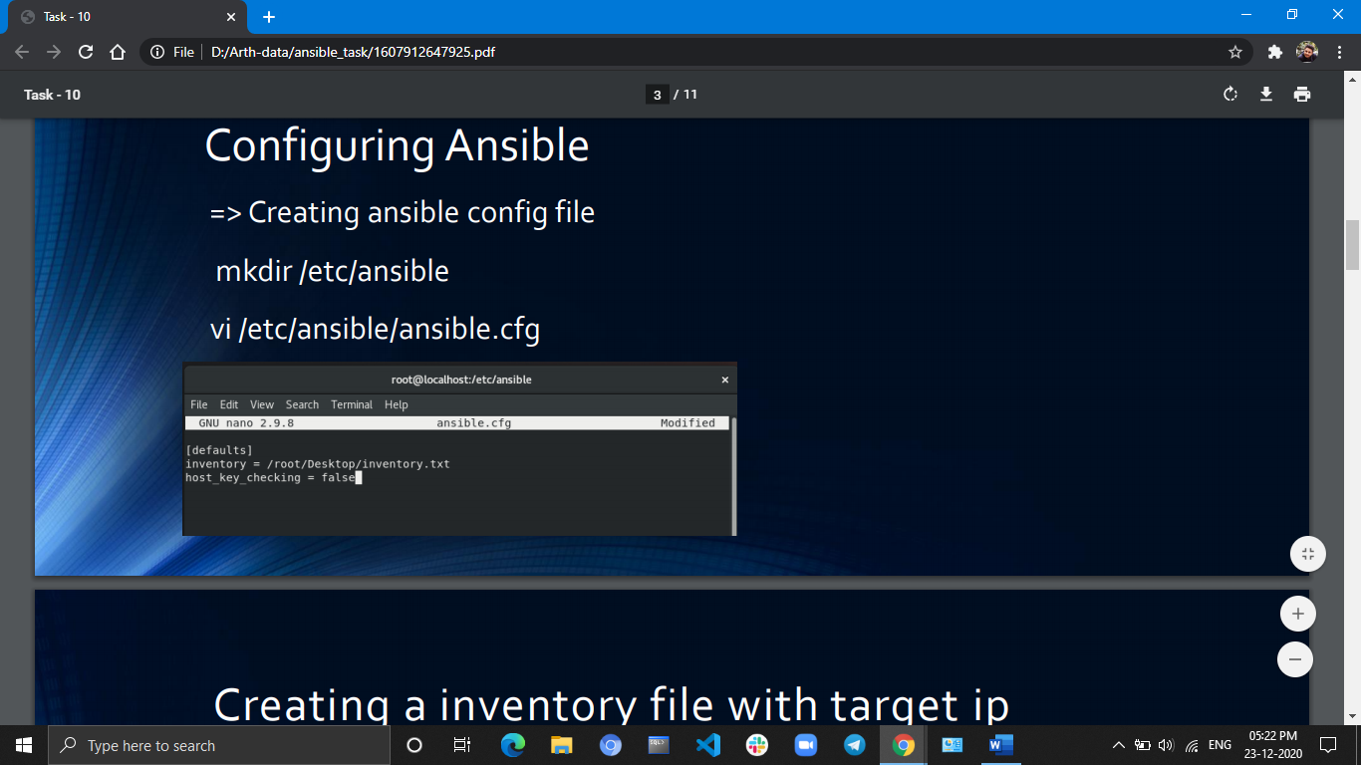

Creating a inventory file with target ip

• **vi inventory.txt**

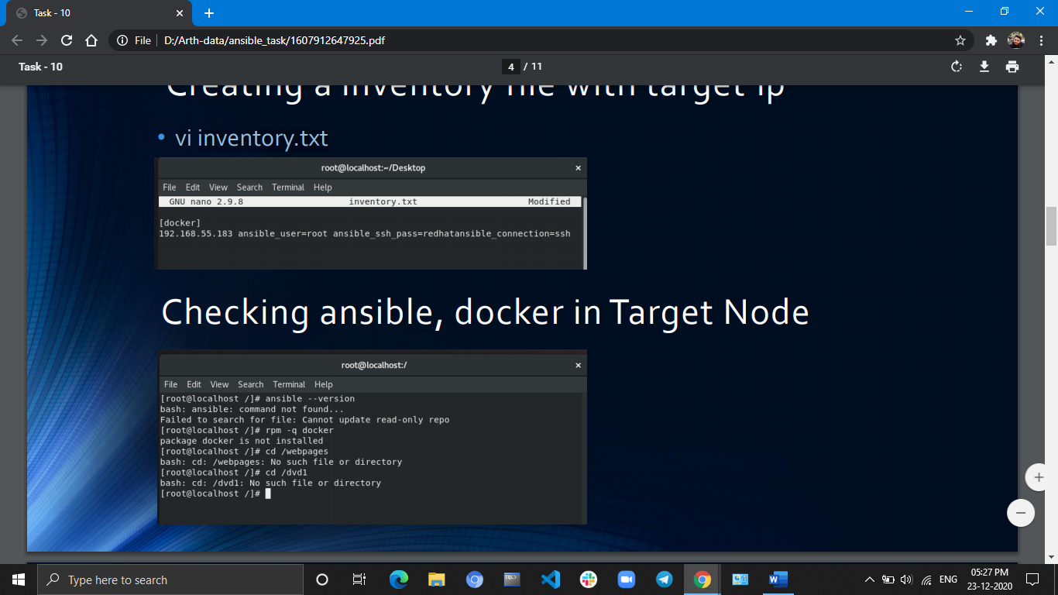

**Checking ansible/docker in Target Node :**

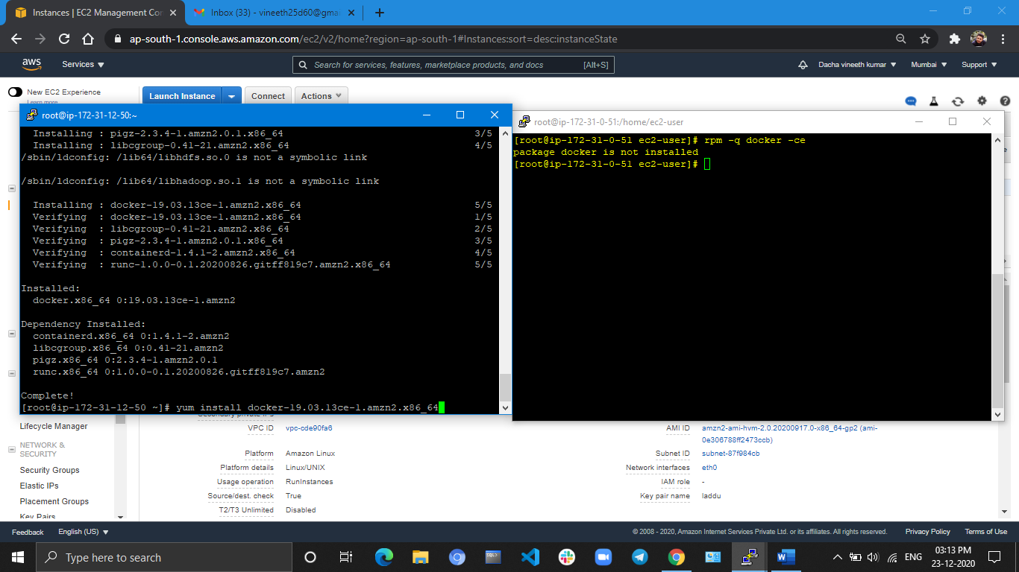

Controller Node

Target Node

**Playbook To do All Tasks in AWS:**

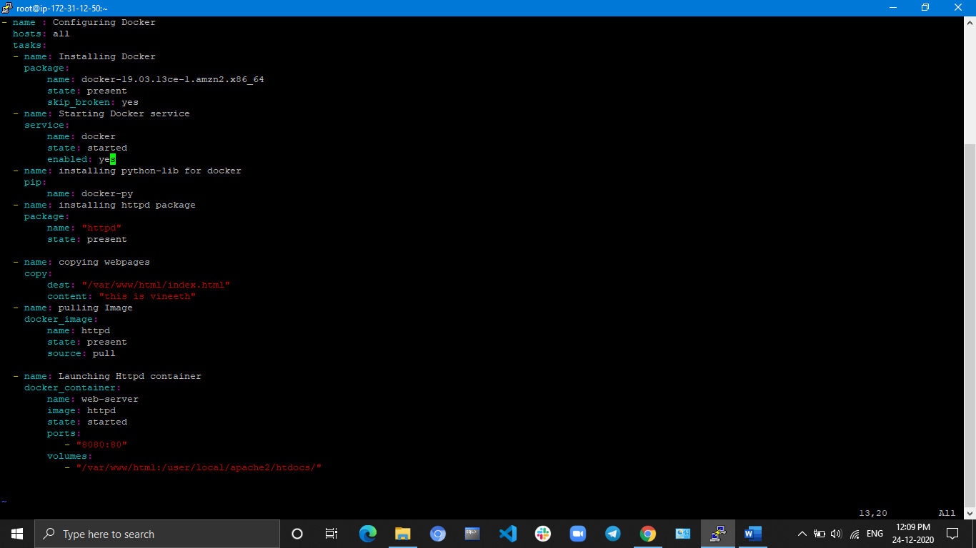

**Playbook To do All Tasks in Rhel8:**

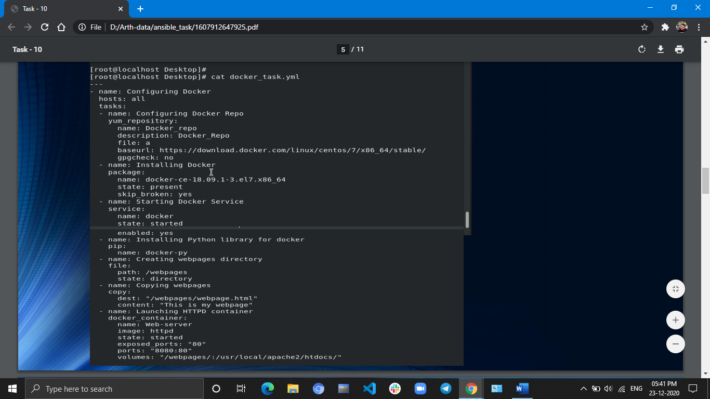

**After running Play-book: ansible-playbook <playbook_name>**

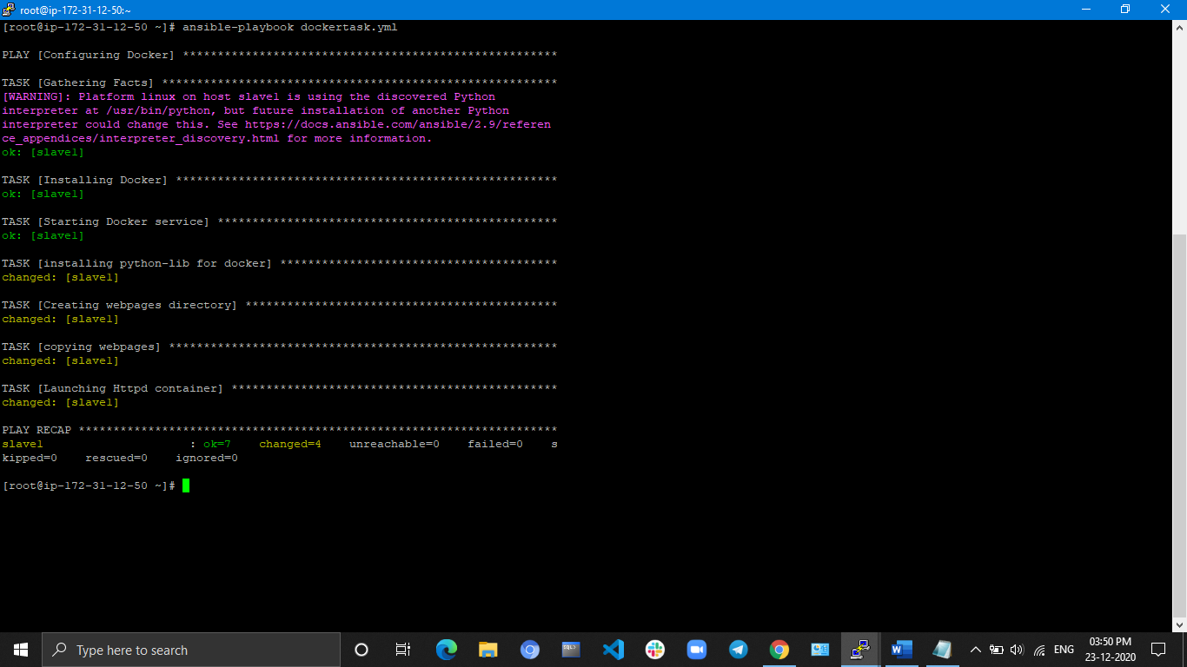

=> **Changes in Target node :**

